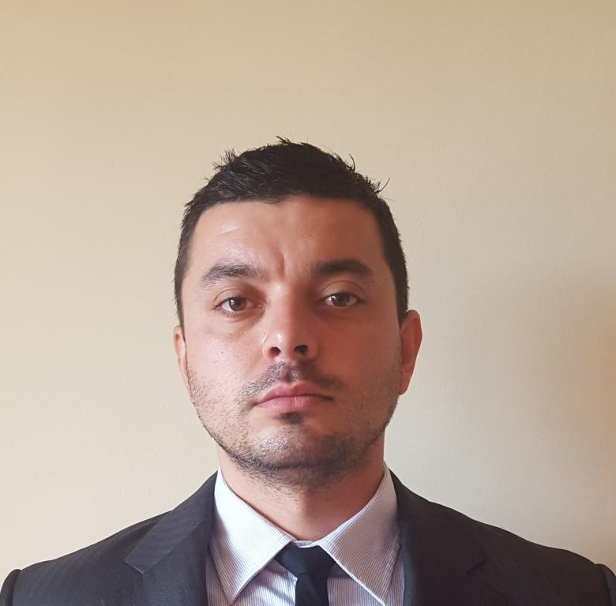

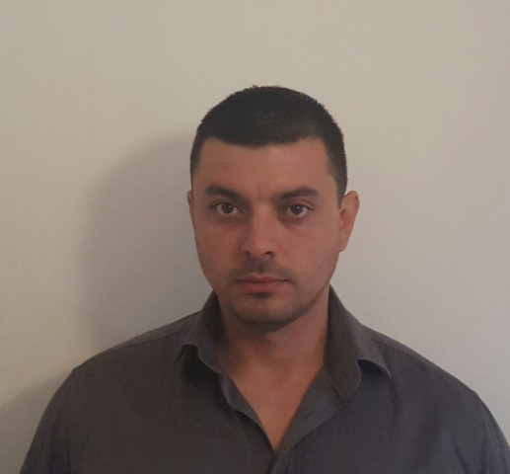

**Svetoslav Bakalov**

**Email:** [**s.bakalov84@gmail.com**](mailto:s.bakalov84@gmail.com)

**Skype: psiho_84**

**Mobile BG: +359(0)876502003**

**Yrs: 31**

**PERSONAL PROFILE:**

Self-motivated, Multilingual and reliable with a proven track record of organizing , monitoring, training and problem-solving under high-stress situations. Qualifications include a wide range of Military experience including assignments with the Horizon Security Ltd ,Special Operations Forces; missions in Afghanistan and conducting close protection operator patrol escorts, convoys, and reconnaissance operations. Strengths include strong interpersonal communication skills, ability to adapt quickly under dynamic operating environments, displaying initiative, and facilitating teamwork in various settings while maintaining honesty and integrity under demanding situations.

Management on Local National

**RELATED EXPERIENCE:**

**Former Military/9 yrs.**

**Military Senior Specialist, Spec.Ops. And Reconnaissance Airborne**

**Ministry of Defence/ 68th Brigade Special Operations Forces/Airborne Regiment**

Executed mission planning to include information operations on prospective hostile zones.

Performed investigative and detainee operations.

Specialized Military Training and experience included CQB Techniques.

High-risk PPO/CPO services and Escort Training.

Search and rescue reconnaissance training.

Premedical training

CQB Training

Tactical insertion and extraction with helicopter by the means of fast rope, rappel and grape.

Close Protection training and tactical driving.

First Aid Course.

Radio Communication training.

Survival in extreme environment course and mountain warfare.

Counter IED course/EODT Team/

**October 2009 – Apr. 2010 (7 months)/Afghanistan/Kabul**

**January 2012 – Aug.2012 (8 months)/Afghanistan/Kabul**

**Support of International Security Assistance Forces (ISAF) Mission as Rifleman.**

Conducted patrols, PSD,CP, escorts and convoy.

Protection of High Risk visits of VIP participants to different public events.

Diplomatic Escorts from Kabul to Kandahar.

**KEY QUALIFICATIONS & TRAINING:**

**Horizon Security Pearson BTEC Level 3 in Close Protection Operations (QCF)**

**Horizon Security Pearson BTEC Level 2 in First Person on Scene Intermediate (FPOSi)**

**Horizon Security Medicine in Remote Areas Course (MIRA)**

**CP-CQB /Viking GARM Academy/**

**WEAPON Qualifications:** AK 47 , AKMS, AK 47 M1 S, GP-25 “KASTJOR” , AR-M12F+Under Barrel Granadе Launcher (UBGL) , H&K MP5 A3, H&K MP5 KN PDW, H&K MP5 SD, PKM, RPG 7 V, RPG 22 “NETO”, ”MAKAROV” handgun(HG), Glock handgun series, CZ 75 ,H&K P30,H&K USP, S&W MP, SIG SP2022

**Certificate of BNAUA (BULGARIAN NATIONAL ASSOCIATION OF UNDERWATER ACTIVITY)**

**WINGTSUN PASSPORT/Self Defense/**

**CCW LICENSE**

**Skills & Expertise**

**PPO/CPO/Risk Assessment/Intelligence Analysis/Reconnaissance/Martial Art instructor.**

**Languages**

**English**-Fluent working proficiency

**Macedonian-**Limited working proficiency

**EDUCATION:**

**EUROPEAN COLLEGE OF ECONOMICS AND MANAGEMENT**

**Law: Military Economics and Management**

**Reference:**

[CP.Instructor@horizon.uk.com](mailto:CP.Instructor@horizon.uk.com) <medman@horizon.uk.com>

**Christopher Kirkbride** **Tom Johnston**

Close Protection Instructor at Horizon Medical Manager at Horizon

[st_pavlin@yahoo.com](mailto:st_pavlin@yahoo.com)

**Pavlin Stoychev**

Major, Chief of Staff 2 SFBn/68SFBde

+359894454124